1. **pwd:-**

The command named ‘pwd’ in Linux displays the current working directory.

Please find the below screenshot.

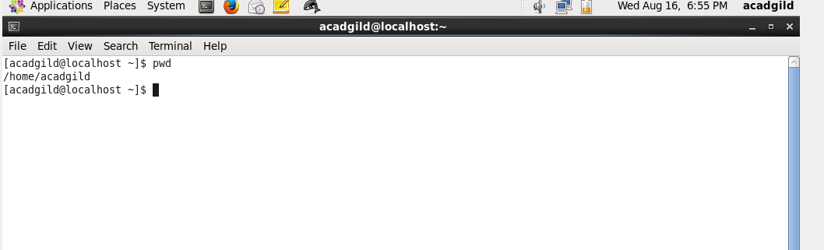

Here the current directory is **/home/acadgild**